ID2209 — Distributed Artificial Intelligence and Intelligent Agents

***Assignment 1 – Festival Event Simulation on GAMA Platform***

*Group 7*

Chang Yang

Jingyi Xiao

Jingmeng Xie

11th. Nov. 2025

**1. Running Instructions**

**Background**

We submit three GAML files and achieve challenges seperately:

**assingment1.gaml** — the baseline for Assignment 1: create three agent types (Guests, Stores, Information Center), ensure distinct visual appearance, make Guests become hungry/thirsty over time, ask the Information Center for directions using ask (when in range), go to the nearest suitable store to replenish, then resume idle wandering in a continuous simulation.

**memory.gaml** — memory.gaml — Challenge 1 (Memory of Agents) on top of the baseline: add per-guest memory of visited stores and an exploration probability; compare distance traveled with and without the memory mechanism.

**assignment1_bonus2.gaml** — Challenge 2 (Removing Bad Behaviour Agents) on top of the baseline: introduce a Security agent; only when a bad guest is reported by another guest at the Information Center will Security be dispatched to chase and die the target, and meanwhile outputing corresponding logs.

# **Step-by-step Running Guide**

1. **Import & Run**Open GAMA → create/open a project → import assingment1.gaml, memory.gaml, assignment1_bonus2.gaml → open each file → click Run. → running more steps and observing the simulating and the expected output.
2. **Observing Exception of assingment1.gaml**  
   Expect green dots (Guests), brown pyramids (FoodStore), light-blue pyramids (DrinkStore), and an orange sphere (InfoCenter). Guests wander; hunger/thirst randomly decrease; when below threshold they ask the InfoCenter and head to the nearest suitable store (red for food, blue for drink). Upon arrival they replenish and return to green/idle, repeatedly. Console prints initial store locations and messages like “is hungry, heading to …” and “ate food at …”. Monitor shows Average distance traveled.
3. **Challenge 1 (memory.gaml)**  
   Guests use a per-agent *memory* of visited stores together with an *explorationProbability*. When hungry/thirsty, a guest either selects a known store from its memory (sorted by current distance) or requests a new one via the InfoCenter. While wandering, agents are green; when heading for food/drink, they turn red/blue respectively. During runs, look for “visited …” lines in the console and track the two monitors: **Average memory size and Average distance traveled**, to compare against the baseline model.
4. **Challenge 2 (assignment1_bonus2.gaml)**

A subset of guests are initialized as bad (drawn in dark red). Normal guests that detect a bad guest within report_distance temporarily head to the InfoCenter and turn purple while reporting. The InfoCenter then dispatches Security (black triangle, faster speed) to chase the reported target. On contact, Security prints “exterminated by Security!” and removes the bad agent via die. Typical logs include:

Spotting message (guest):

Guest X spotted Guest Y (Bad) and is heading to InfoCenter to report.

Dispatch message (InfoCenter):

InfoCenter received report and sent Security after: Guest Y

Extermination message (Security/target):

Guest Y: exterminated by Security!

You should also see the bad agent disappear from the scene after removal.

**Expected inputs and how to provide them**

Experiment parameters (global inputs). The following parameters control the simulation and can be edited either (i) in the global block of each .gaml file or (ii) at run time in GAMA’s Parameters panel after launching the main experiment.

| **Parameter** | **Meaning** | **Default / Source** |
| --- | --- | --- |
| nb_guests, nb_foodstores, nb_drinkstores, nb_infocenter | Number of agents per species | 15 / 3 / 3 / 1 |
| location_infocenter | InfoCenter position (x,y) | {50,50} |
| size_infocenter | Arrival radius for the InfoCenter | 5 |
| world_dimension | Map size; guests wander in [0, world_dimension]^2 | 100 |
| speed_guests | Guest movement speed | 3.0 |
| hungerlevel, thirstlevel | Per-step maximum random decrease (used by rnd(...)) | 10.0 / 10.0 |
| speed_security | Security speed (Challenge 2); defined as speed_guests * 1.5 | derived |
| report_distance | Radius within which a bad guest can be reported (Challenge 2) | 10.0 |

Per-guest input (Challenge 1).

*explorationProbability* controls the choice between exploring via the InfoCenter or exploiting the agent’s own memory of known stores. Default: 0.3 (30% exploration).

How to provide inputs.

Open GAMA and run the main experiment of the chosen model: assingment1.gaml, memory.gaml, or assignment1_bonus2.gaml.

Adjust the parameters in the right-hand Parameters panel; click Apply (or re-launch) to take effect.

**species & behaviors**

| **Species** | **Key attributes / actions** | **Core reflexes (executed each step)** | **Aspect** |
| --- | --- | --- | --- |
| **guest** (skills: [moving]) | hunger, thirst, guestName, color, randomDestination, target: stores; setName(int) | **determineTarget** (when target = nil): randomly decrease hunger/thirst; if either < 50, ask infoCenter for the nearest matching store and set target (red/blue color). **normalState** (when target = nil): choose a random point in [0, world_dimension]^2 and goto it. **moveToTarget** (when target != nil): move toward the current target. **arrivedStore**: on arrival, reset hunger or thirst to 100, clear target, set color back to green, and write a log line. | Green circle (turns red/blue while seeking food/drink) |
| **stores** (abstract) | sellsFood, sellsDrink | — | — |
| **foodStore : stores** | sellsFood <- true | — | Brown pyramid |
| **drinkStore : stores** | sellsDrink <- true | — | Light-blue pyramid |
| **infoCenter : stores** | foodstores, drinkstores (precomputed lists), hasLocations | **listStoreLocations** (once): print the locations of all stores, then set hasLocations <- true. | Orange sphere |

**Monitors**: display of all species; console logs indicating hunger/thirst decisions and service at stores.

**Challenge 1 (memory.gaml) — per-guest memory**

| **Species** | **Extensions vs. baseline** | **Core changes** |
| --- | --- | --- |
| **guest** | Adds memory: list<stores> (visited stores), totalDistance, last_location (for distance accumulation), and explorationProbability. | **trackDistance**: accumulate distance traveled each step. **determineTarget**: when hungry/thirsty, with probability 1 - explorationProbability pick the nearest suitable store from memory; otherwise query the InfoCenter for a new one. **arrivedStore**: after service, add the visited store to memory (deduplicated), reset state, and write "visited …" logs. Additional monitors: **Average distance traveled** and **Average memory size**. |

**Challenge 2 (assignment1_bonus2.gaml)—reporting & security**

| **Species** | **Key attributes / actions** | **Core reflexes (executed each step)** | **Aspect** |
| --- | --- | --- | --- |
| **guest** | isBad <- flip(0.15), isReported; other attributes as baseline | **reportBadGuest** (when !isBad && target = nil): if an unreported bad guest is within report_distance, set temporary target <- one_of(infoCenter), turn purple, and log a spotting message. **arrivedInfoCenter**: on arrival, the InfoCenter marks one bad guest as reported and enqueues it into Security.targets; then the reporter clears its target and resumes normal behavior. Other reflexes (targeting stores, movement, arrival) as in the baseline. | Dark-red for bad guests; green/purple for others depending on state |
| **Security** (skills: [moving]) | targets : list<guest> (queue of bad guests to chase) | **patrol** (when targets empty): wander. **catchBadGuest** (when targets non-empty): goto the first target using speed_security. **badGuestCaught**: upon contact, print “exterminated by Security!” and die the target; then remove it from the queue. | Black triangle |
| **infoCenter** | Continues to provide store directories; also dispatches Security during the reporting flow. | — | — |

**Communication pattern.**

Guest ↔ InfoCenter: guests ask for the nearest store or report a bad guest; the InfoCenter writes back a target or dispatches Security.

Guest ↔ Store: on arrival, the store updates the guest’s state; in Challenge 1 the guest also records the store in memory.

**2. General Overview**

**Solution Summary:**

the simulation initializes a 100×100 map with 1 InfoCenter at {50,50} (arrival radius size_infocenter=5), **3** food stores, **3** drink stores, and **15** guests; guests move at speed_guests=3.0. In the step-by-step loop, if a guest has **no target**, it wanders randomly within the map and is shown in **green**; simultaneously, its hunger/thirst decrease each step by a random amount up to hungerlevel=10.0 and thirstlevel=10.0. When either need **drops below 50** and the guest still has no target, the guest uses ask to query the InfoCenter for the **nearest matching store**: if hungry, it turns **red** and heads to the nearest food store; if thirsty, it turns **blue** and heads to the nearest drink store, moving via goto. Arrival is detected when the distance to the target is **< 2.5**. Upon arrival, the guest resets the corresponding need to 100, clears its target, returns to **green**, writes an arrival log, and resumes random wandering. This yields a continuous loop of “wander → need triggered → ask → travel → replenish → reset → wander again.”

1. **Section Reports**

**Section 1: Environment & Parameters**

**What this section requires**

Set up the global festival environment and tunable parameters: world size, counts and positions of InfoCenter/shops/guests, speeds, and arrival radii.

**How we approached it**

Declared all parameters in *global* (e.g., *world_dimension = 100*, *location_infocenter = {50,50}*, *size_infocenter = 5*, population and shop counts, *speed_guests*, *hungerlevel/thirstlevel*). Instantiated all species in *init* and assigned guest names.

**Code snippets screenshot**

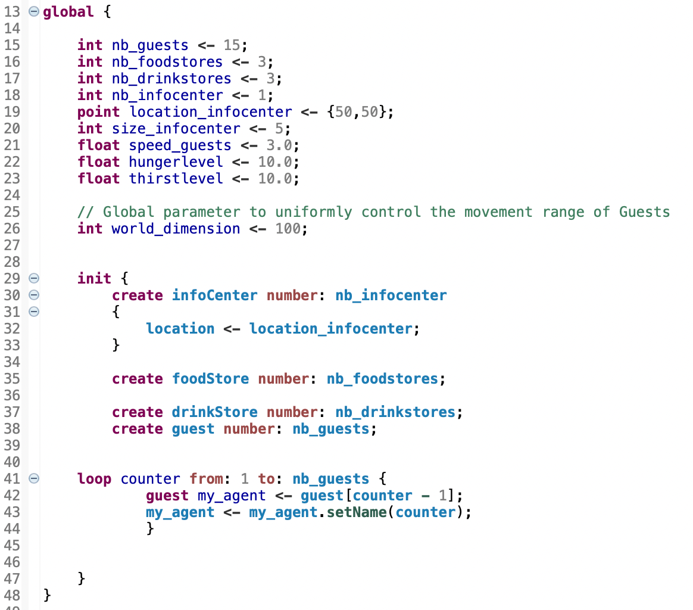

**What it does**

Defines global parameters (numbers of guests/stores, InfoCenter position/size, movement speed, random decay magnitudes for hunger/thirst, and world size). In init, it creates all agents and assigns names to each guest (“Guest 1…N”).

**Section 2: Species Design**

**What this section requires**

Define the entity types and their minimal attributes/appearance: *guest*, *foodStore*, *drinkStore*, and *infoCenter*.

**How we approached it**

Implemented *species guest skills:[moving]* with attributes *hunger*, *thirst*, *guestName*, *color*, *target*, and a default *aspect*.

Created an abstract *stores* type with boolean *sellsFood/sellsDrink*, then derived *foodStore* and *drinkStore* with distinct shapes/colors.

Defined *infoCenter* as a dedicated species (orange sphere) responsible for lookup/printing.

**Code snippets screenshot**

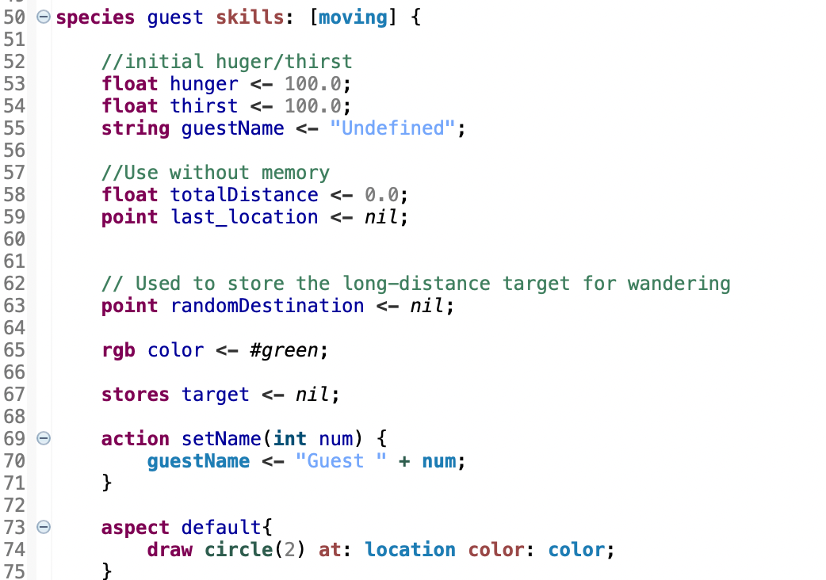

**What it does**

Defines the guest’s state (hunger, thirst, name, color, current target, wandering waypoint) and its appearance (a small green circle). The moving skill enables motion primitives such as goto.

**Section 3: Needs Dynamics (Hunger & Thirst)**

**What this section requires**

Decrease hunger/thirst over time and trigger a “find store” routine once a threshold is reached.

**How we approached it**

In *reflex determineTarget when: target = nil*, subtract a random value each step using *rnd(hungerlevel/thirstlevel)*. If either value drops below 50 and no target is set, proceed to target selection.

**Code snippets screenshot**

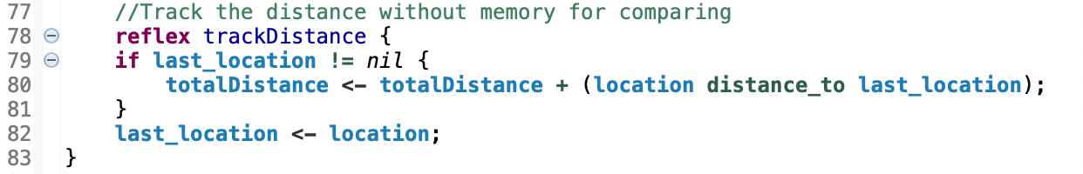

**What it does**

On every simulation step, accumulates the guest’s traveled distance into totalDistance (using the previous location) for later monitoring.

**Section 4: Target Selection via InfoCenter**

**What this section requires**

When a need is active, select the nearest matching store (food or drink) through the InfoCenter.

**How we approached it**

Used *ask one_of(infoCenter)* and nearest-neighbor queries *(one_of(foodStore/drinkStore closest_to myself*)) to set *guest.target*. Encoded intent with colors (hungry → red, thirsty → blue) and printed directional logs.

**Code snippets screenshot**

**A-decide target**

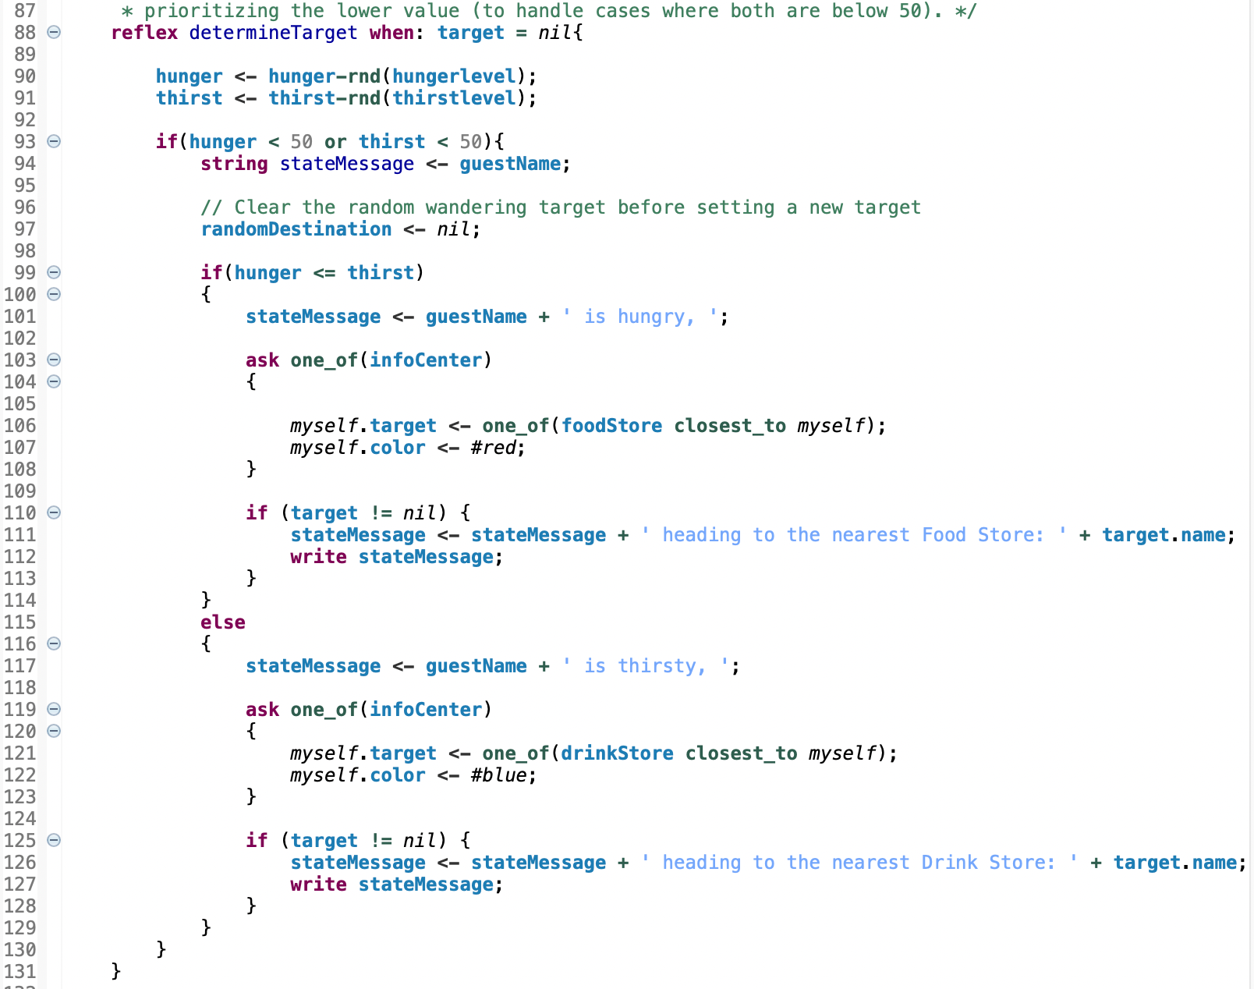

1. **default wandering**

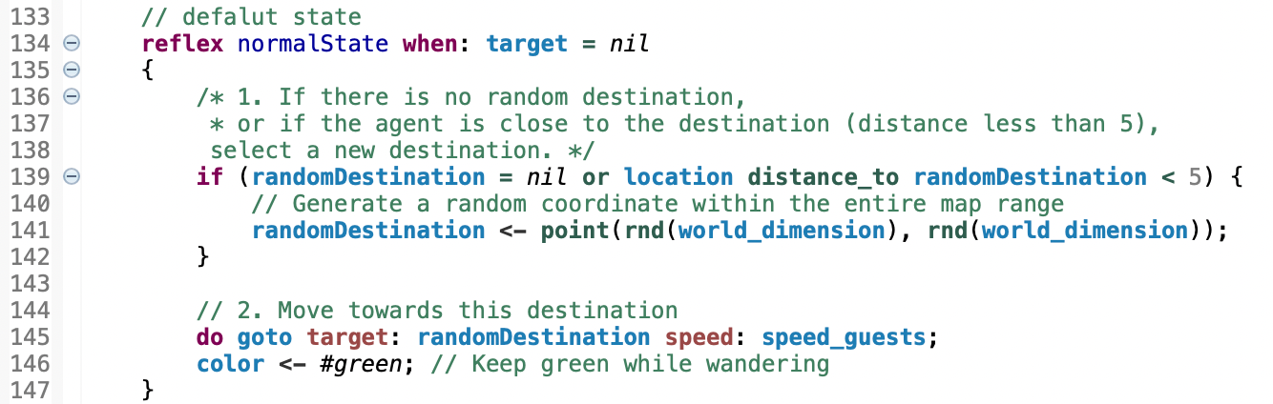

**What it does**

A – decide target: When the guest has no target, it randomly decreases hunger/thirst. If either drops below 50, it queries the infoCenter for the nearest appropriate store and changes color (red for food, blue for drink), while logging the intent and destination.

B – default wandering: If no refill is needed, the guest picks a random point within the map and wanders toward it (stays green). Using a random destination instead of a simple wander helps prevent guests from accumulating near a recently visited store, thereby expanding their movement range across the map.

**Section 5: Navigation & Wandering**

**What this section requires**

Wander within the map when idle; move straight to the target when one exists.

**How we approached it**

Maintained *randomDestination*; if empty or “close” (< 5), sample a new in-bounds point. Executed *do goto target: randomDestination speed: speed_guests* while idle (green).

If *target != nil*, *reflex moveToTarget* navigates via *goto target.location*.

**Code snippets screenshot**

1. **move to target**

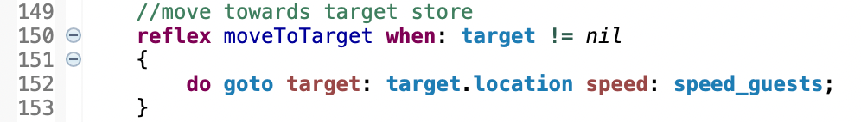

1. **arrival at store**

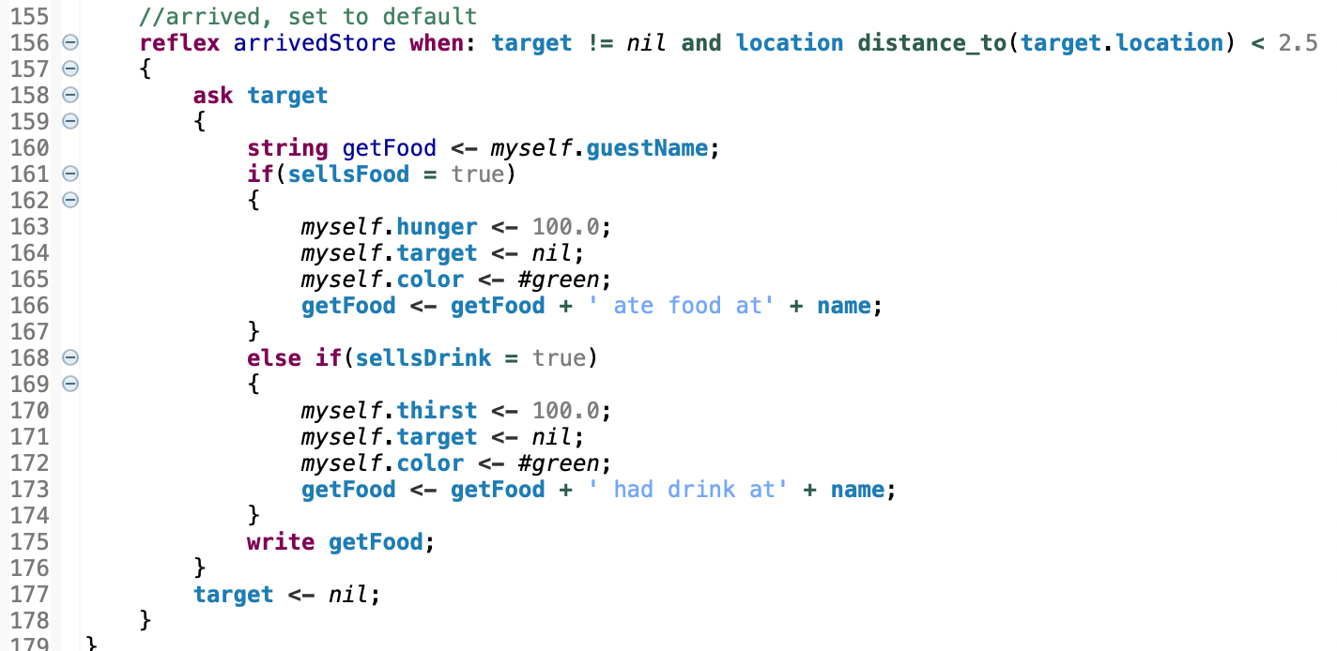

**What it does**

A – move to target: Moves toward the current store’s location at the configured speed.

B – arrival at store: Upon arrival, restores the corresponding state to 100 (hunger or thirst), returns to wandering (green), and prints a log message describing the visit.

**Section 6: Arrival, Service & Reset**

**What this section requires**

Detect arrival at a store, restore the corresponding need, and return to idle wandering.

**How we approached it**

Declared arrival when *distance_to(target.location) < 2.5*. Within *ask target*, reset *hunger* or *thirst* to *100*, clear *target*, switch color back to green, and log “ate food / had drink” messages.

**Code snippets screenshot**

1. **store& infocenter species**

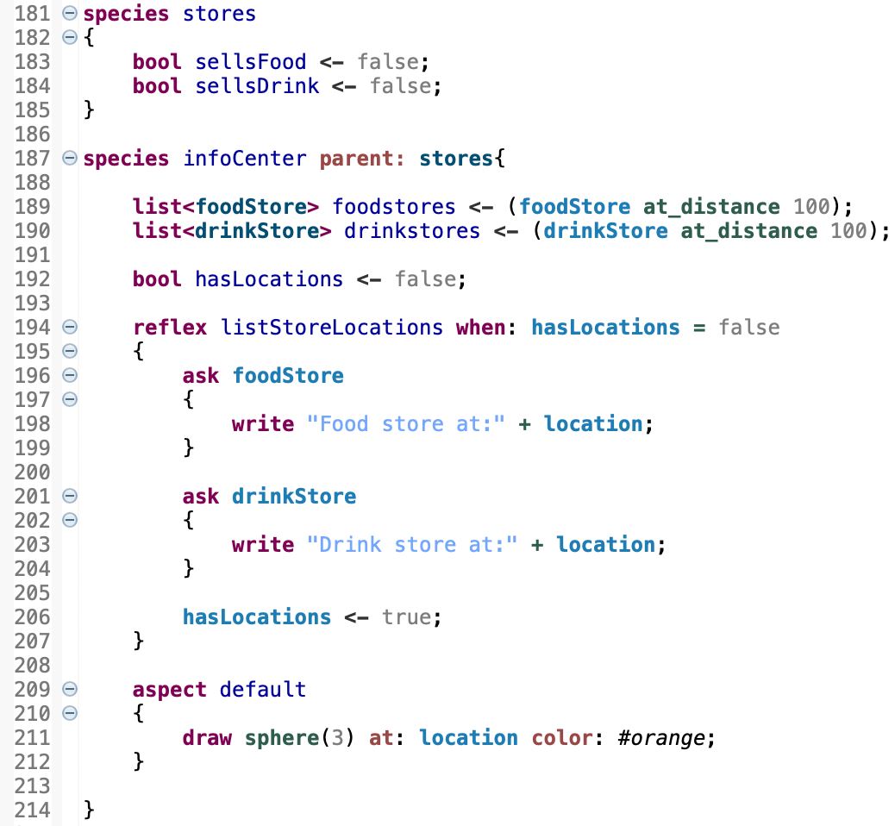

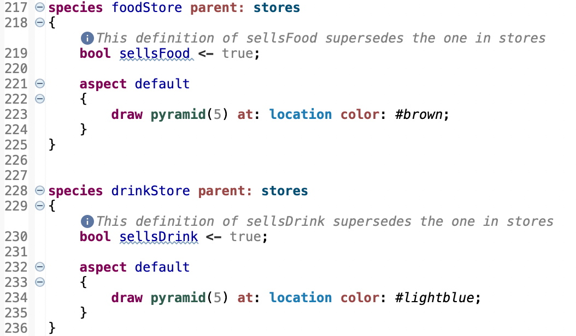

1. **experiment& monitors**

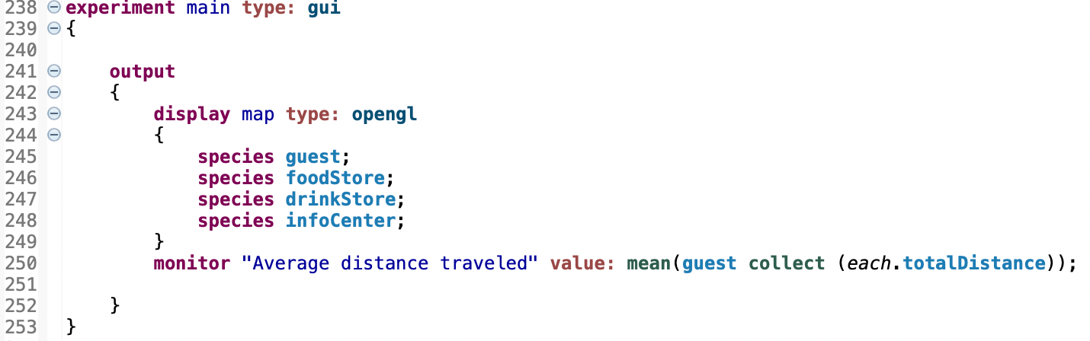

**What it does**

stores is a base class; infoCenter maintains store catalogs and prints all store locations once on the first step, and is drawn as an orange sphere; foodStore/drinkStore inherit from stores, set their respective flags, and define their visual appearance.

B – experiment & monitors:

Defines the GUI experiment: displays all four species on an OpenGL canvas and shows a live monitor for “Average distance traveled” (the mean of guests’ cumulative distances).

**Section 7: Visualization & Monitoring**

**What this section requires**

Provide a unified GUI display and a simple monitor so TA can run and verify behavior quickly.

**How we approached it**

In *experiment main → display map type: opengl*, rendered all four species (guest/foodStore/drinkStore/infoCenter). Added a monitor (e.g., average distance) to support later comparisons or checks.



**Section 8: Logging & Traceability**

**What this section requires**

Ensure key state transitions and choices are visible in the console for verification.

**How we approached it**

Emitted three core log families:

Need trigger & destination (e.g., “Guest k is hungry/thirsty, heading to …”);

En-route status (color/target changes);

Completion at store (e.g., “ate food at … / had drink at …”).

The logs plus color coding provide a clear, auditable behavior trace.

**Code snippets screenshot**

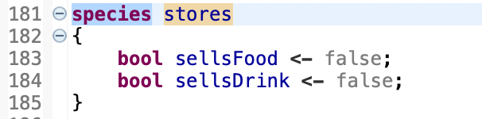

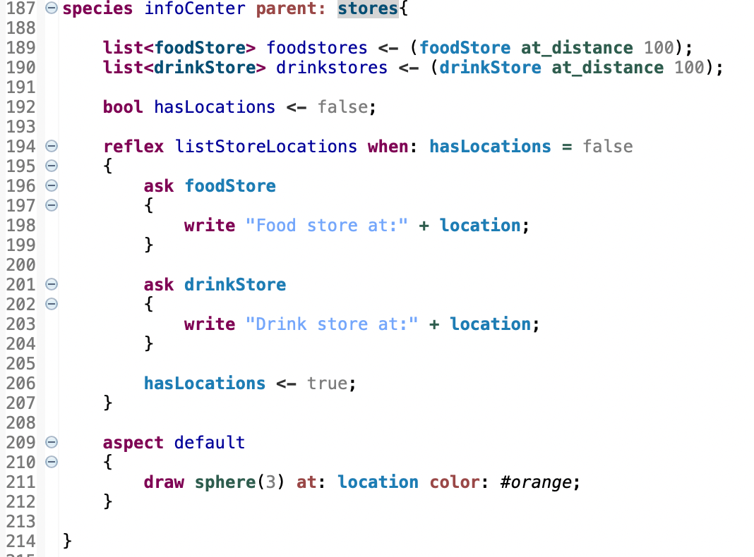

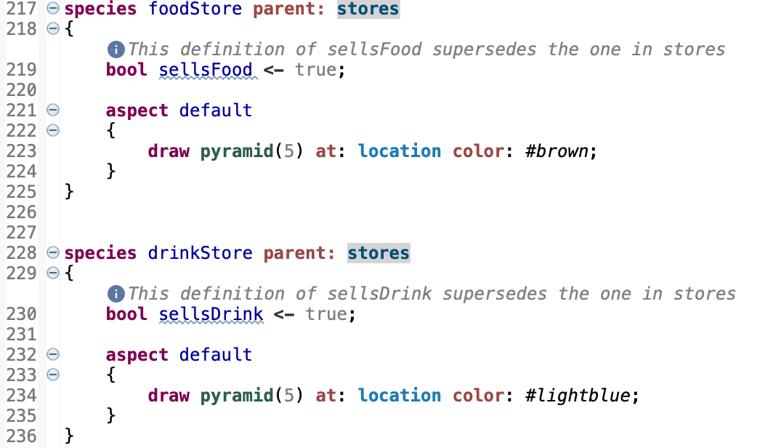

**What it does**

stores (base class): An abstract parent species that defines two flags, sellsFood and sellsDrink, used to distinguish store types so guests can decide whether they will be resupplied with food or drink after arrival.

infoCenter (inherits from stores): Acts as a directory.

Pre-computes two lists of nearby stores—foodstores and drinkstores

On first run, the listStoreLocations reflex prints the location of all food and drink stores to the log once (guarded by hasLocations).

Visualized as an orange sphere via its aspect for easy identification.

foodStore / drinkStore: Concrete store species that set the corresponding flag (sellsFood = true or sellsDrink = true) and are rendered with distinct aspects—brown pyramid for food stores and light-blue pyramid for drink stores.

Interaction with guests: In determineTarget, a guest calls ask one_of(infoCenter) to obtain the nearest appropriate store (food or drink) from the directory, which then drives the guest’s subsequent movement and replenishment behavior.

**Demonstration**

**Use Case 1 — Hunger trigger: query InfoCenter, go to nearest food store, reset after eating**

**1) Input description**

Model file: assingment1.gaml (baseline / festival).

Key parameters (default values are sufficient)

nb_guests = 15, nb_foodstores = 3, nb_drinkstores = 3, nb_infocenter = 1

location_infocenter = {50,50}, world_dimension = 100

speed_guests = 3.0, hungerlevel = 10.0, thirstlevel = 10.0

**2) Screenshot of program execution/output**

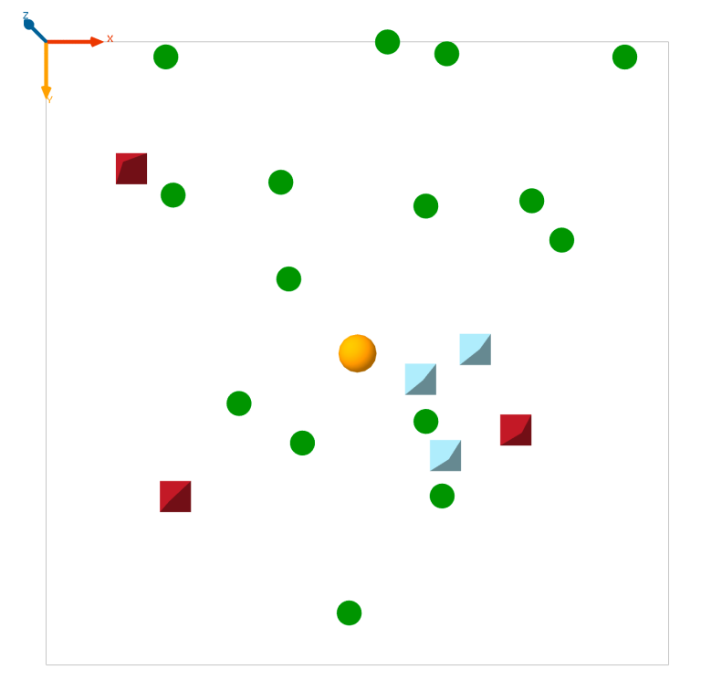

Fig. 1A (Initialization)

Exception: green circles (guests, ≈15), brown pyramids (foodStore, ≈3), light-blue pyramids (drinkStore, ≈3), and an orange sphere (infoCenter at ~{50,50}).

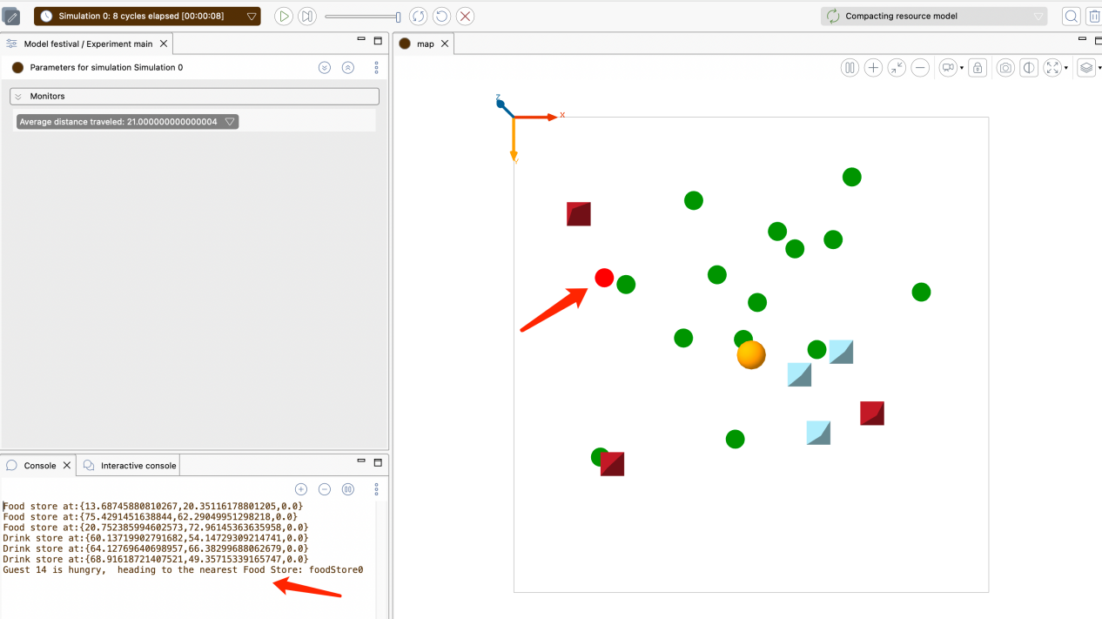

Fig. 1B (Trigger + nearest food store selection)

Expection:after playing several steps,

Guest k is hungry, heading to the nearest Food Store: <StoreName>(with log)

On the canvas, the corresponding guest turns red and moves toward that food store.

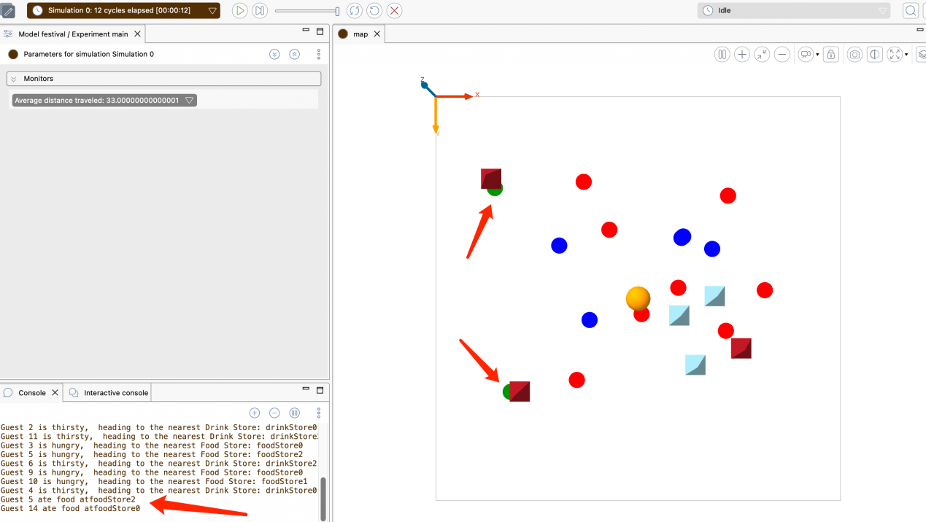

Fig. 1C (Arrival, eating, and reset)

Continue until arrival (distance < 2.5). The console shows:

Guest k ate food at <StoreName>

The guest turns back to green, target is cleared, and the agent resumes wandering.

**3) Short interpretation of the result**

When hunger drops below the threshold, determineTarget asks the InfoCenter for the nearest food store; the guest turns red and moves using goto (handled by moveToTarget).

On arrival, arrivedStore resets hunger to 100, clears target, restores green color, and prints “ate food at …”. This validates the full loop: need trigger → directory query → navigation to the nearest matching store → service → reset.

────────────────────────────────

**Use Case 2 — Thirst trigger + random wandering when idle & distance monitor**

**1) Input description**

Same as Use Case 1. To trigger faster, raise thirstlevel to 15. Keep the Average distance traveled monitor visible.

**2) Screenshot of program execution/output**

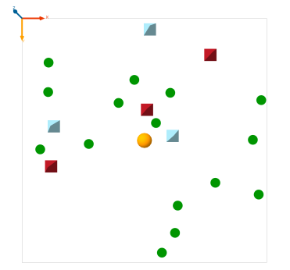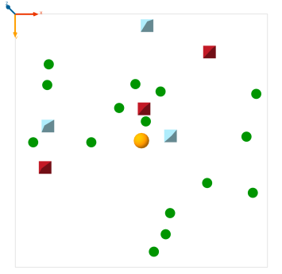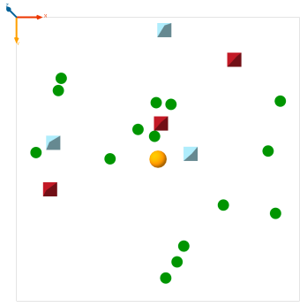

Fig. 2A (Idle random wandering)

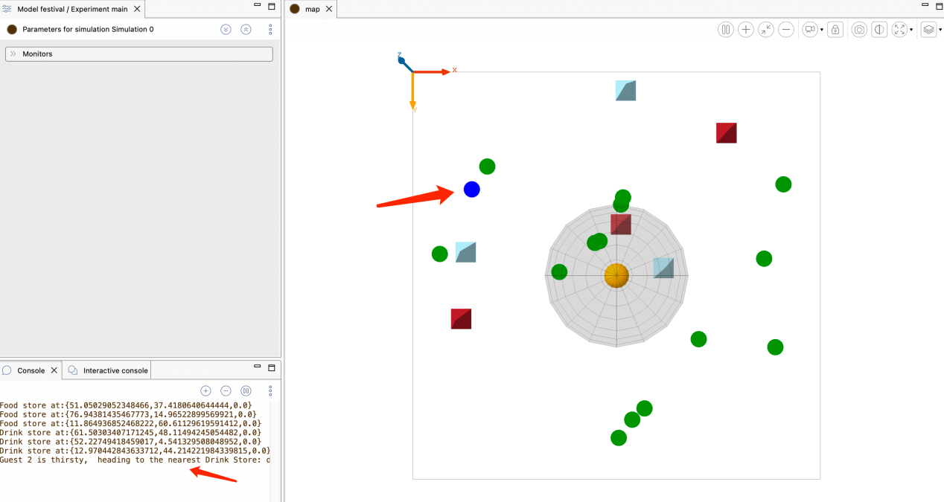

Fig. 2B (Thirst → nearest drink store)

Expection: console shows:

Guest m is thirsty, heading to the nearest Drink Store: <StoreName>

The guest turns blue and heads to that drink store.

Fig. 2C (Arrival, drinking, reset + monitor)

Expection:On arrival the console shows:

Guest m had drink at <StoreName>

The guest turns back to green and resumes wandering.

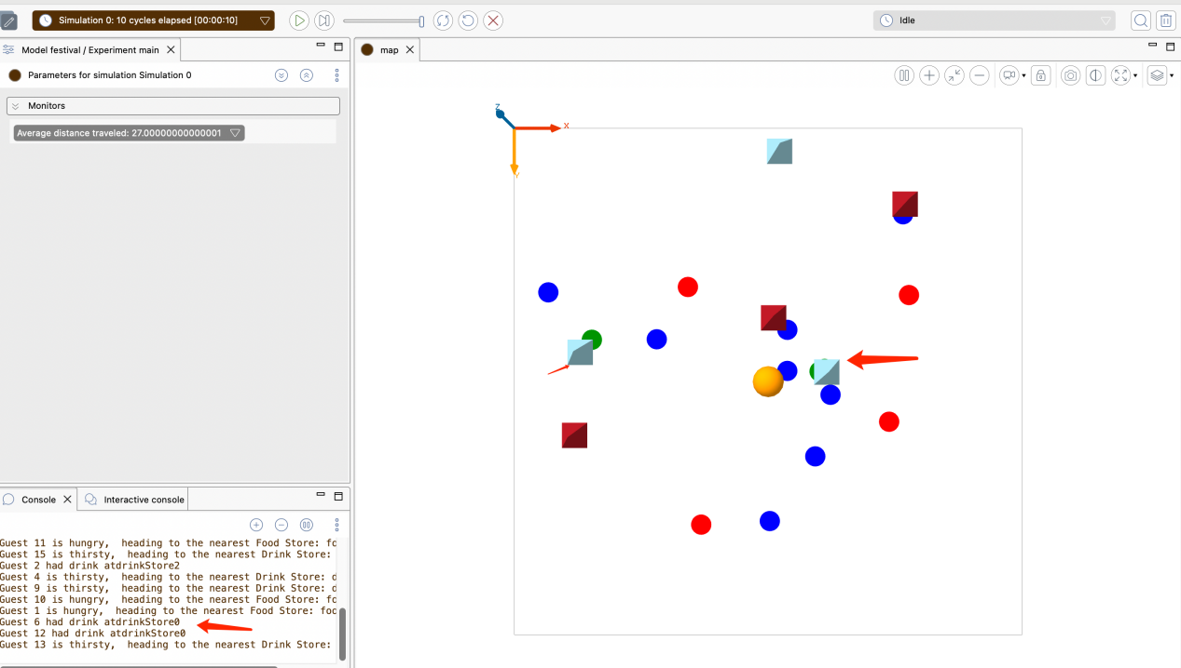

**3) Short interpretation of the result**

When thirst drops below the threshold, the guest queries the InfoCenter for the nearest drink store, turns blue, and moves directly to it. Upon arrival, thirst resets to 100, target is cleared, and the color returns to green.

The Average distance traveled monitor increases with steps, confirming the cumulative distance logic (trackDistance) correctly aggregates both idle wandering and goal-directed movement, providing a quantitative metric for later comparisons.

1. **Challenge 1&2**

**Challenge1-Memory of Agents - Small Brain**

**Explanation**

**What the challenge is about.**

Agents should remember shops they have already visited, but still explore new places with some probability. The goal is to implement per-guest memory and an exploration probability, then compare the average distance traveled with and without memory (baseline vs. memory version).

**Our approach.**

We added four key elements to the guest species:

1.A memory list of visited stores,

2.A trackDistance reflex to accumulate traveled distance,

3.A target-selection policy that prefers the nearest suitable store from memory unless a random draw (controlled by explorationProbability) triggers exploration via InfoCenter, and

4.A memory-update reflex that adds a store when the guest arrives.

We then instrumented the experiment with monitors to report Average distance traveled and Average memory size, enabling a direct comparison to the baseline over short and long runs. As shown in the evaluation table in the PDF, the memory mechanism produces negligible gains at very short horizons but progressively reduces distance once agents have accumulated ~4–5 remembered stores.

**Code snippets screenshot**

(Note: The snippets below are exactly the parts that implement the memory logic and measurement.)

(A) Memory, distance tracking, exploration control (guest attributes)



Logic:

Each guest maintains a personal list of known stores, keeps a running sum of distance traveled, and decides whether to explore or exploit memory based on *explorationProbability*.

(B) Distance tracking (guest reflex)

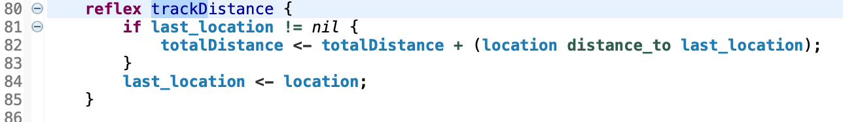

Logic:

At every step, add the displacement to *totalDistance*, providing a quantitative metric to compare baseline vs. memory scenarios.

(C) Target selection using memory vs. exploration (guestreflex)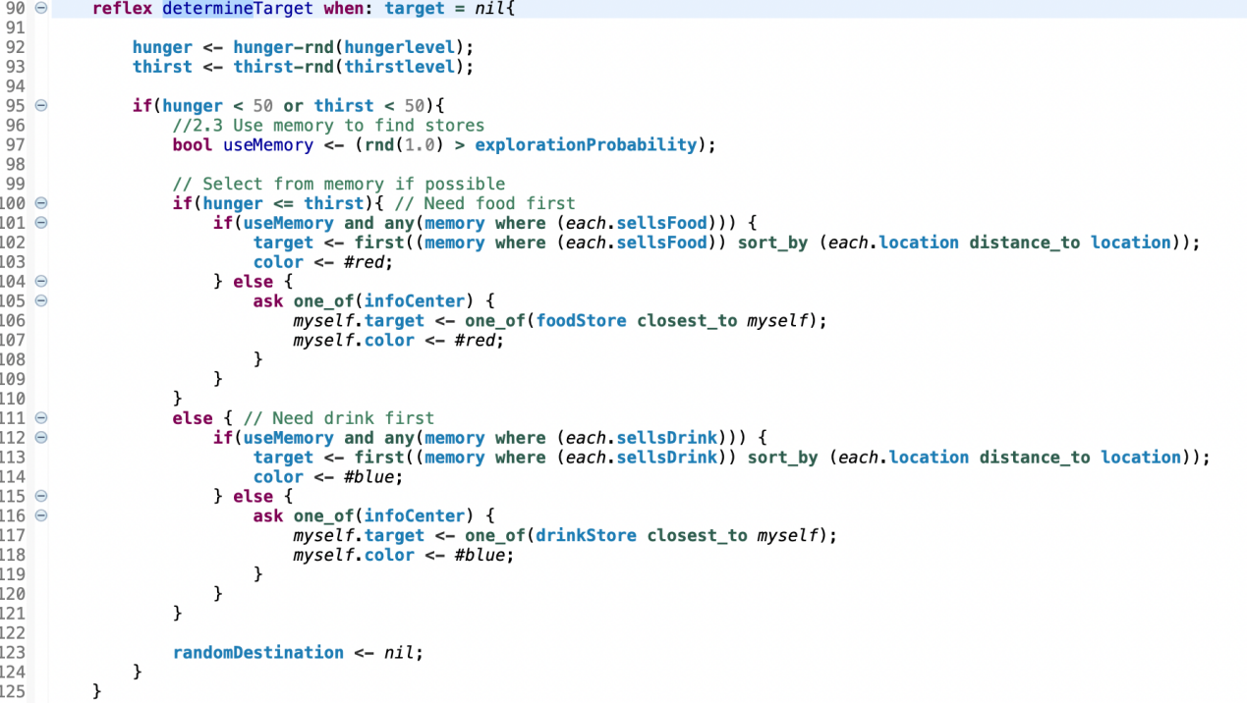

When hungry/thirsty, a guest either exploits (pick the nearest matching store from *memory*) or explores (ask *infoCenter* for the nearest store), with the choice governed by e*xplorationProbability*. Color reflects the current need.

(D) Memory update on arrival (guest reflex)

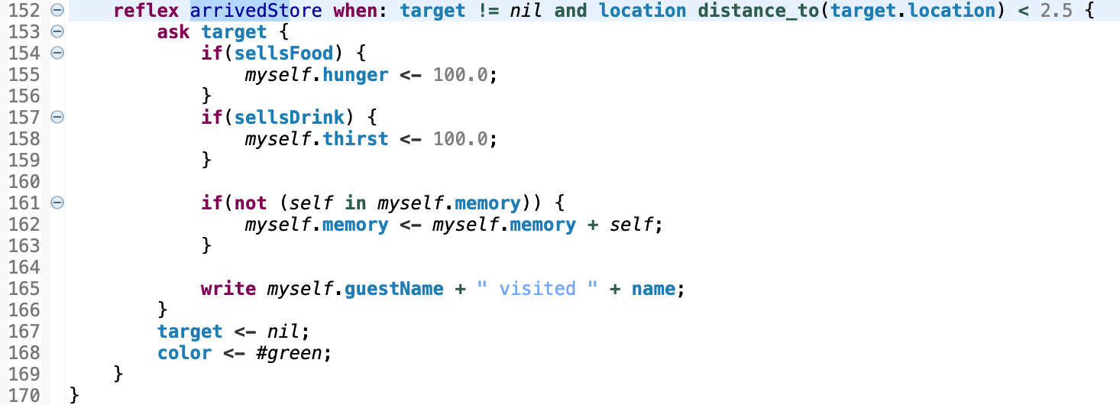

Upon reaching a store, the guest restores the relevant need, records the store in memory, logs the visit, and returns to idle. The visit log (“visited …”) is useful for checking memory formation.

(E) Monitors in the experiment (for evaluation)



These monitors replicate the evaluation in the PDF and let us compare baseline vs. memory runs over different durations (short vs. long).

**Demonstration**

**Use Case 1 — Short-run comparison (≈ 100 cycles)**

1) Input description

Models:

Baseline: assignment1.gaml

Memory: memory.gaml (with explorationProbability = 0.3)

Shared parameters (both models): nb_guests = 15, nb_foodstores = 3, nb_drinkstores = 3, world_dimension = 100, speed_guests = 3.0, hungerlevel = 10.0, thirstlevel = 10.0.

Procedure:

Open each model, start the main experiment, and run 100 cycles.

1. Screenshot of program execution/output

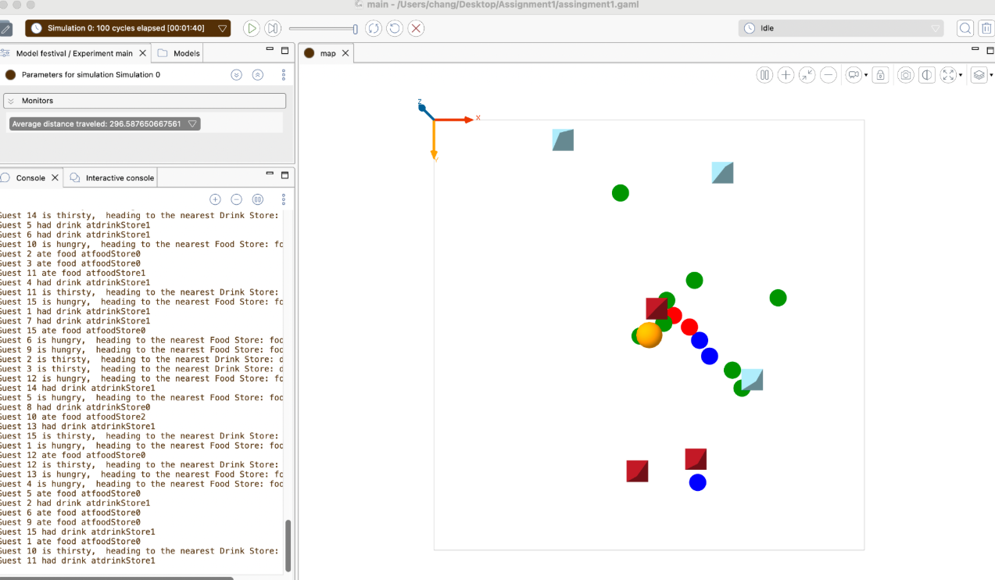

Figure A — Baseline (100 cycles)

assignment1.gaml at 100 cycles (Map + Console + “Average distance traveled” monitor ≈ 296.59).

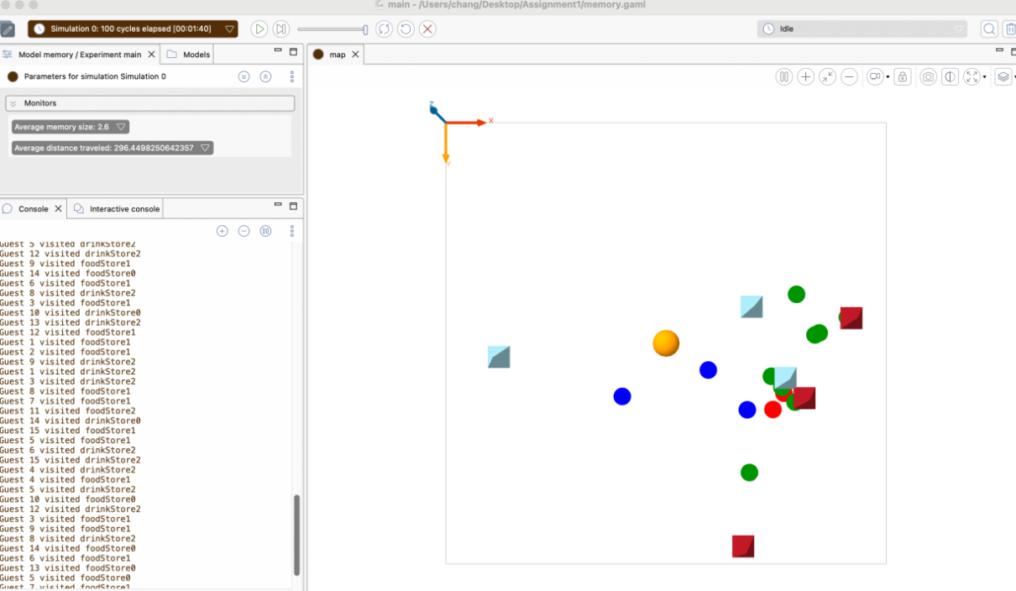

Figure B — Memory (100 cycles)

Your screenshot: memory.gaml at 100 cycles (Map + Console + “Average distance traveled” ≈ 296.45 and “Average memory size” ≈ 2.6).

3)Result and Explanation

In 100 cycles the distances are very close; the memory feature has started to accumulate (avg. memory ≈ 2.6), but its effect on distance is still modest at this horizon.

The memory variant behaves as designed (guests record visited stores and sometimes reuse them).

Over longer runs or with a lower explorationProbability, we expect the memory model to reduce average distance more noticeably relative to the baseline.

**Use Case 2 — Long-run comparison (≥ 3,000 cycles)**

Input description

Files:

Baseline: assignment1.gaml

Memory: memory.gaml

Parameters (keep defaults): nb_guests=15, nb_foodstores=3, nb_drinkstores=3, speed_guests=3.0, world_dimension=100, in memory.gaml leave explorationProbability=0.3.

Procedure:

Open the baseline model and run experiment to ~3,000 cycles.

Repeat with memory.gaml, run to ~3,000 cycles

Screenshot of program execution/output

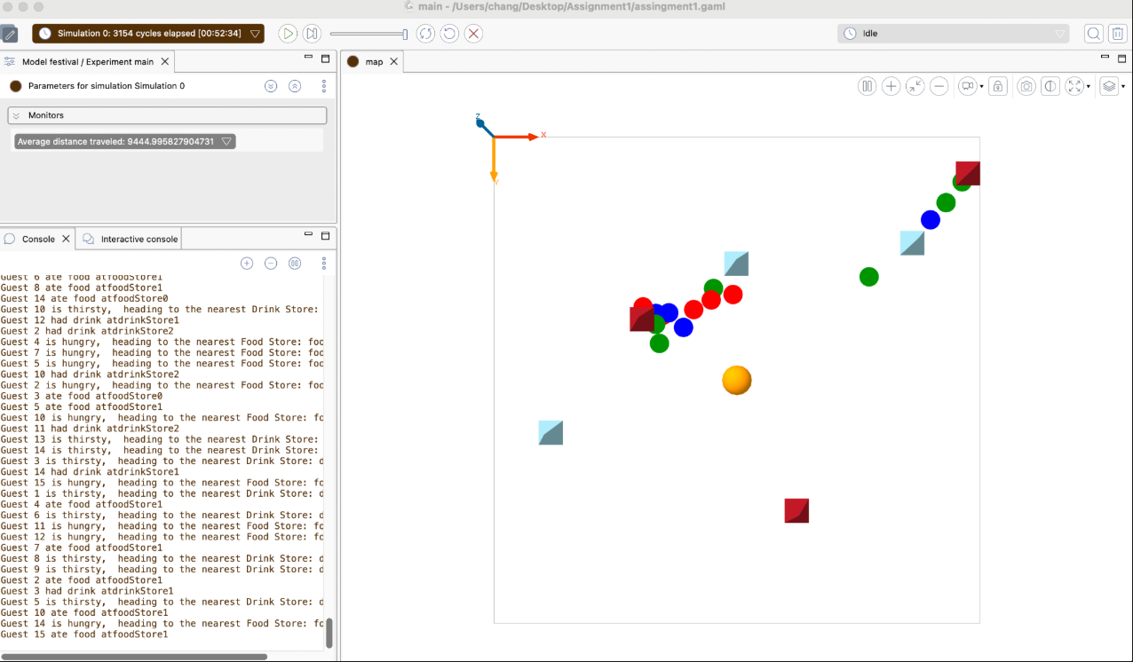

Baseline at ~3,154 cycles — average distance traveled ≈ 9444.996 (left monitor), with console logs of route choices via InfoCenter and consumption events.

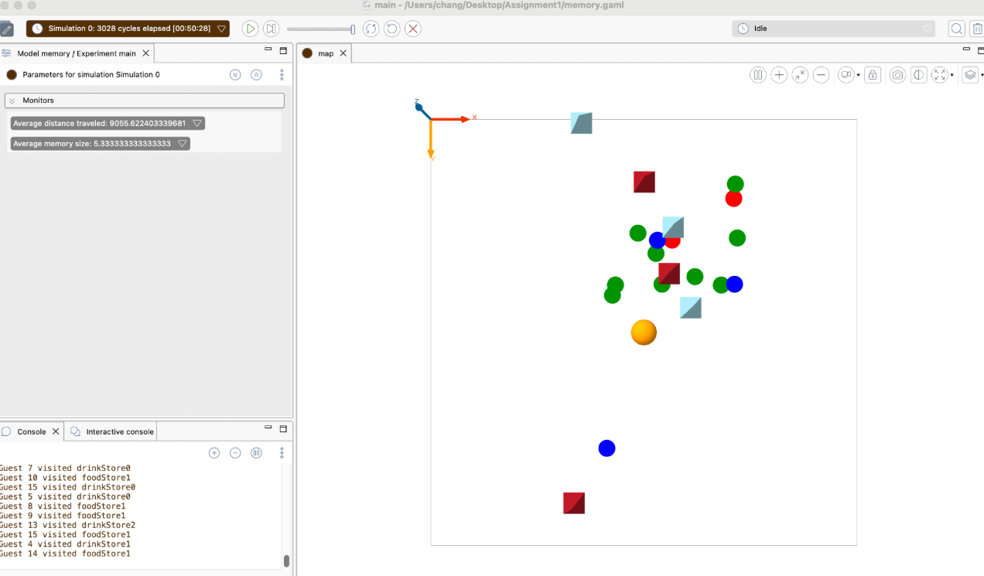

Memory at ~3,028 cycles — average distance traveled ≈ 9055.622, average memory size ≈ 5.33, and console logs “Guest X visited foodStoreY/drinkStoreY”.

Short interpretation of the result

After a significant number of steps, the memory model shows a lower average distance traveled than the baseline (≈9056 vs. ≈9445 in the provided runs, ~4% reduction).For more rounds data, kindly refer to attached file memory.pdf

Reason: once guests start remembering visited stores, many trips are resolved by selecting a known nearby option (sorted by distance) rather than always requesting guidance from the InfoCenter; exploration still occurs (probability 0.3), so the memory keeps growing (avg ≈5.3) and prevents path lock-in.

**Use Case 3 — Sensitivity to explorationProbability**

1) Input description

Compare two runs of memory.gaml with different explorationProbability values:

Run A (low exploration): explorationProbability = 0.0 (pure exploitation of memory).

Run B (high exploration): explorationProbability = 0.8 (strong exploration).

Keep other parameters at their defaults (e.g., nb_guests = 15, nb_foodstores = 3, nb_drinkstores = 3, speed_guests = 3.0, world size 100).

Run each simulation for ~1,200–1,300 cycles.

2) Screenshot of program execution/output

Run A (~1300 cycles): screenshot provided — Monitors show Average memory size ≈ 2.0, Average distance traveled ≈ 3893.53; Console lists many “visited …” logs; Map shows guests and shops.

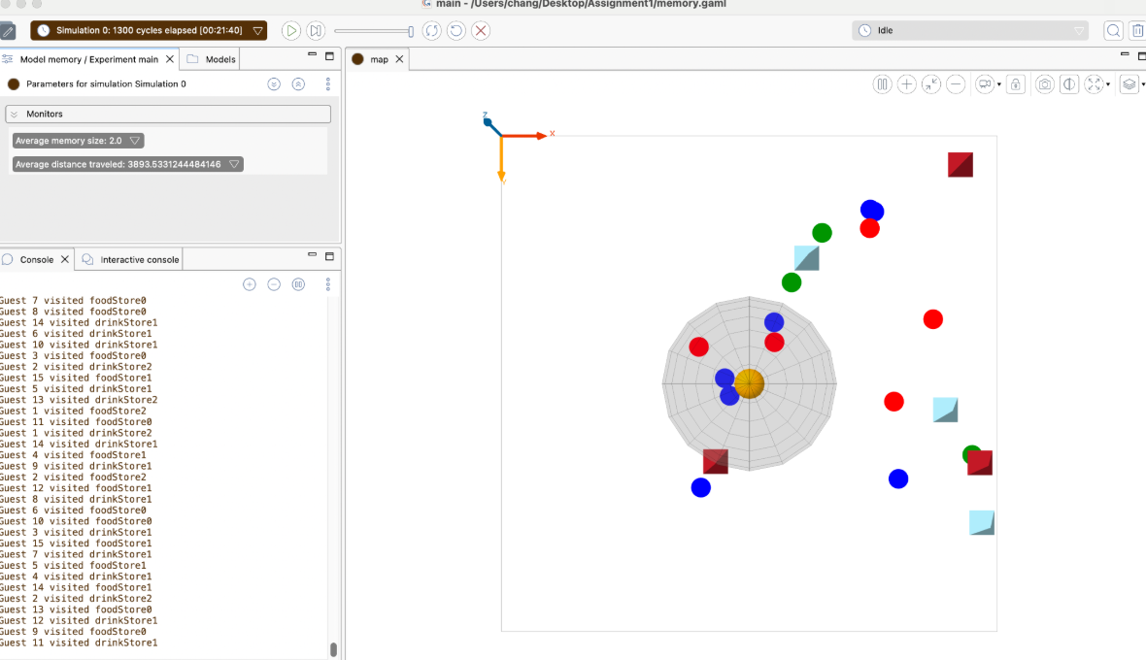

Run B (~1200 cycles): screenshot provided — Monitors show Average memory size ≈ 5.87, Average distance traveled ≈ 3600.25; Console shows broader coverage of visited stores; Map indicates more dispersed refueling points.

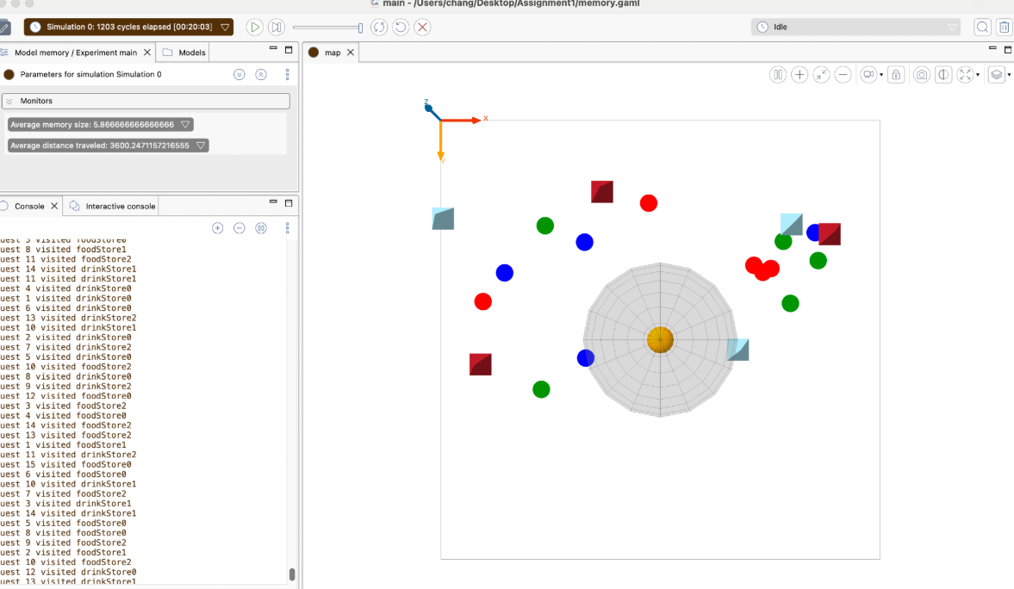

3) Short interpretation of the result

Memory growth: Higher exploration (Run B) substantially increases the Average memory size (≈5.87 vs 2.0), meaning guests discover and remember more stores.

Travel efficiency: With a similar number of steps, the Average distance traveled is lower under higher exploration (≈3600 vs ≈3894). Early exploration helps build a richer, closer set of known stores; later, guests exploit memory (sorted by distance) and walk less overall.

Trade-off: Non-zero exploration incurs some extra movement early on, but the growing memory yields lower distances later. Zero exploration tends to lock into the few initially encountered stores, keeping paths longer on average.

According to the screenshot:

Monitors: higher Average memory size and, after sufficient cycles, lower Average distance traveled for the high-exploration run.

Console: both runs have “visited …” messages; the high-exploration run shows a wider variety of store IDs.

Map: high exploration typically yields more dispersed, multi-store activity clusters; low exploration concentrates around a few early stores.

How to reproduce

Open memory.gaml → set explorationProbability to 0.0 → run ~1,300 cycles → capture Monitors + Console + Map; then set it to 0.8 and repeat. Compare Average memory size and Average distance traveled across the two screenshots.

**Use Case 4 — Memory Accumulation Over Time**

1) Input description  
Run memory.gaml with default parameters. Let the simulation proceed for ~1,000–1,200 steps (no manual changes). We simply observe how per-guest memory grows as agents keep visiting stores.

2) Screenshot of program execution/output

Include both of your screenshots:

Shot A (≈1,126 cycles): shows Average memory size ≈ 4.4 and Average distance traveled ≈ 3,370. Console lists many lines like “Guest X visited foodStoreY / drinkStoreZ”.

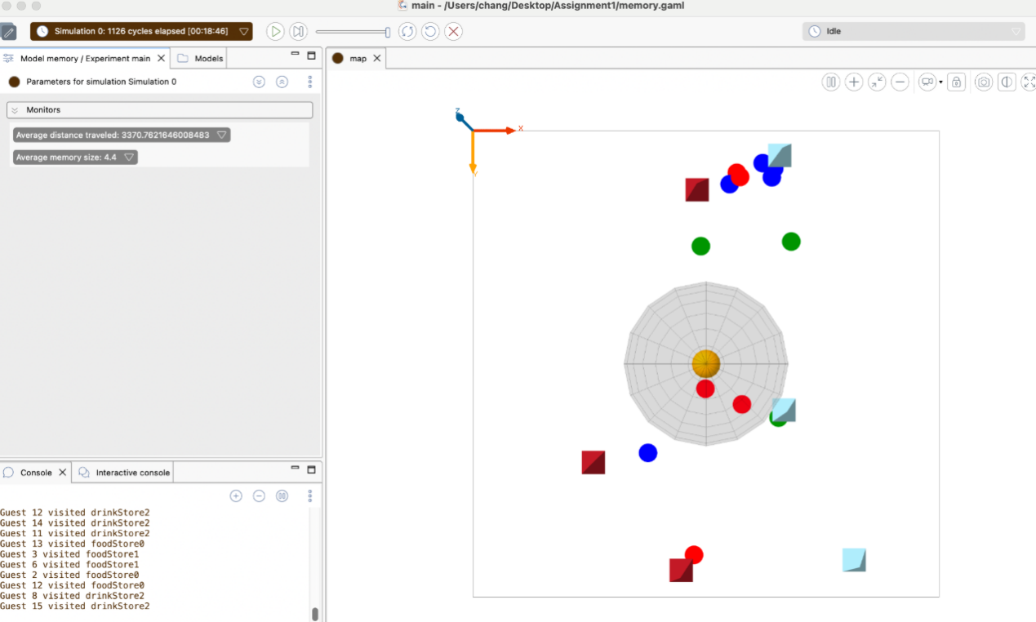

Shot B (≈1,052 cycles, another run of similar length): shows Average memory size ≈ 6.07 and Average distance traveled ≈ 3,119, again with “visited …” logs in Console.

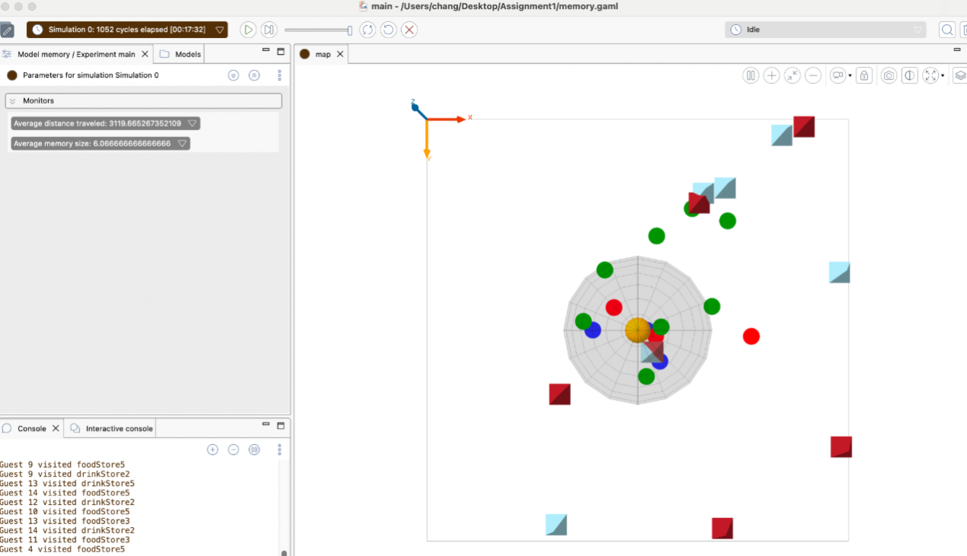

3) Short interpretation of the result

As guests continue to explore and revisit stores, their memory list grows (higher Average memory size). With more known options, guests more often choose the nearest remembered store, which reduces the average travel distance compared with earlier in the run. The repeated “visited …” log lines confirm ongoing discoveries that feed the memory, while the map shows several agents clustering around familiar stores—evidence of memory being reused.

**Challenge2-Removing Bad Behaviour Agents**

**Explanation**

**What the challenge is about.**

On top of the baseline festival, introduce a class of “bad guests.” When a normal guest detects a bad guest within report_distance, the guest temporarily heads to the InfoCenter to report. The InfoCenter then dispatches a Security agent (black triangle, higher speed) to chase the reported target; upon contact, Security prints “exterminated by Security!” and removes the bad agent from the scene (die).

**Approach to solving it.**

Add two flags to guest: isBad (randomly assigns a subset as bad) and isReported (whether the bad guest has been reported).

In reflex reportBadGuest, if a normal guest finds an unreported bad guest within range, it sets the InfoCenter as a temporary target and turns purple to indicate the reporting mission.

On arrival at the InfoCenter, the guest triggers the reporting routine: the InfoCenter chooses an unreported bad guest and pushes it into Security.targets, printing a dispatch log.

Security moves faster and processes its targets queue in order. On contact with the current target, it prints the extermination message and calls die, then pops the target and proceeds to the next one.

**Code**

(A) Global parameters and init

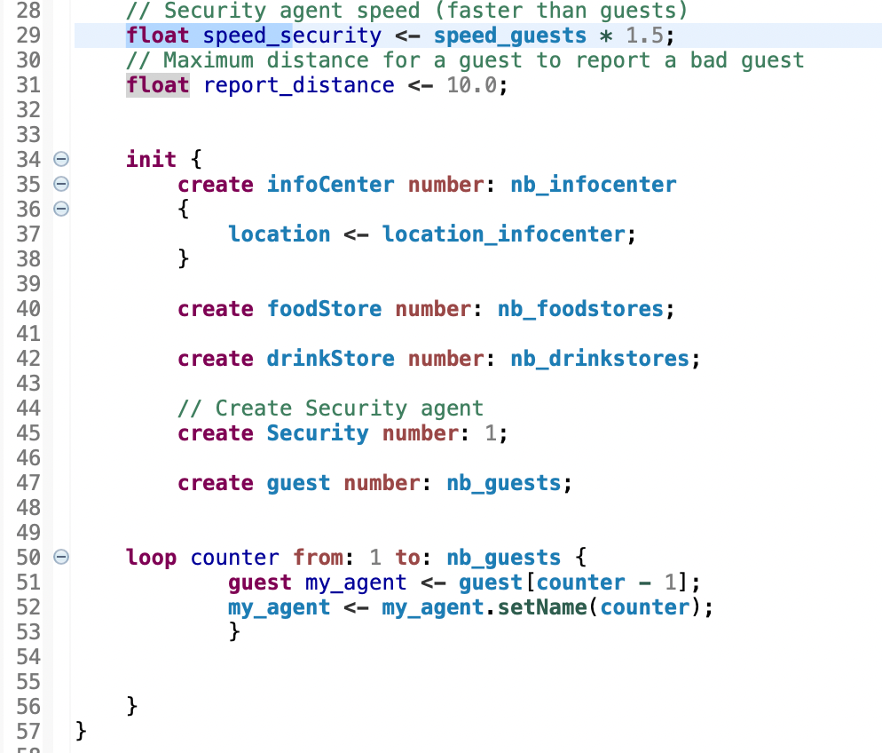

What it does

Defines security speed and reporting radius; creates the InfoCenter, stores, Security, and guests, and assigns guest names.

(B) guest species: flags and appearance

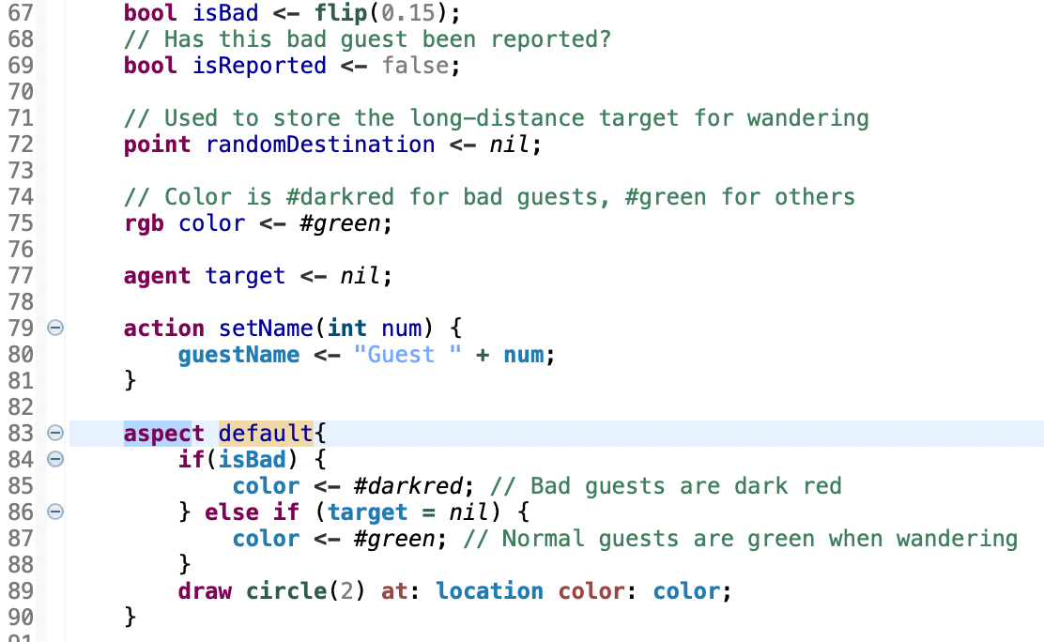

What it does  
Adds bad/reported flags and sets color by state for easy visual inspection.

(C) Detection and reporting

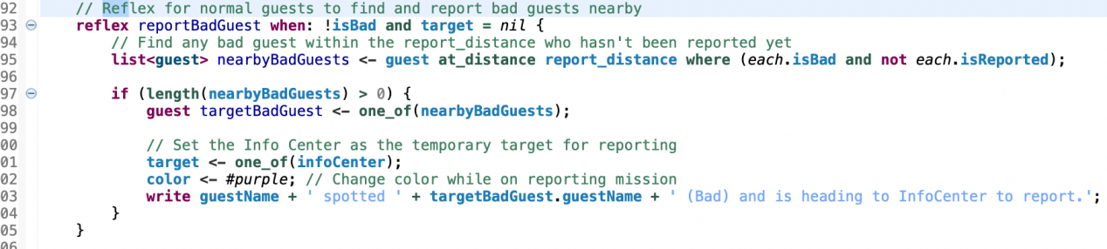

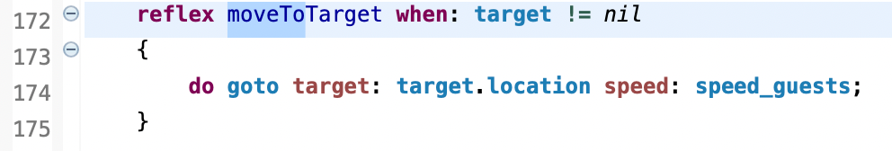

What it does

Normal guests that detect unreported bad guests turn purple and set the InfoCenter as their temporary target. A spotting log is printed; the guest moves toward the InfoCenter.

(D) Reporting at the InfoCenter and dispatching Security

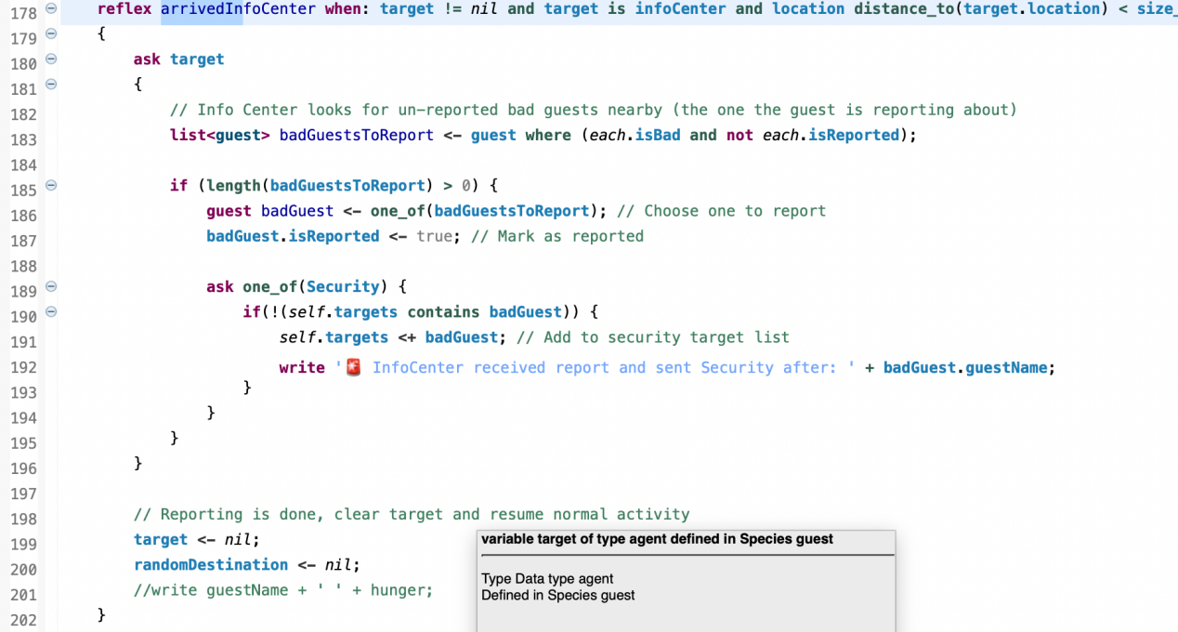

What it does

On arrival, the InfoCenter selects an unreported bad guest, marks it as reported, pushes it into Security.targets, and prints the dispatch message. The reporter returns to normal wandering.

(E) Security species: patrol, chase, and removal

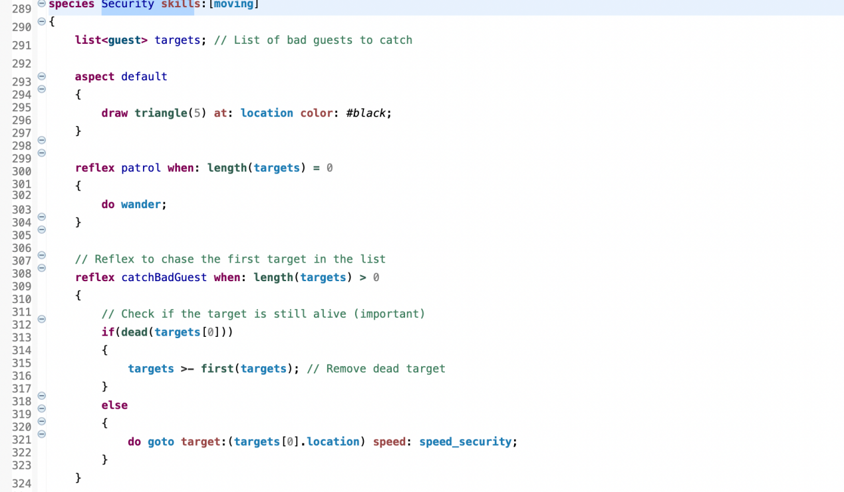

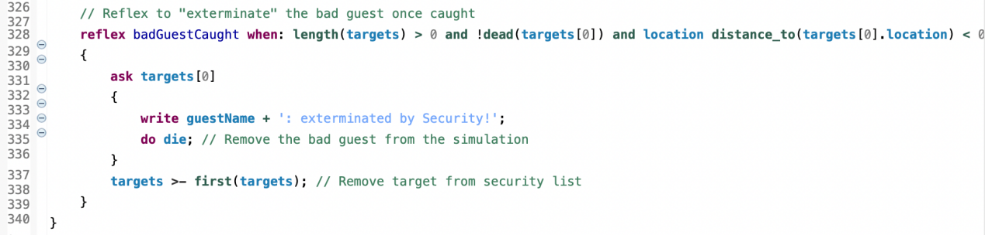

What it does

Security wanders if idle; otherwise it chases the head of its queue at higher speed. On contact it prints the extermination message, removes the target (die), and pops it from the queue.

**Demonstration**

**Use Case 1 — Reporting and dispatch (guest → InfoCenter → Security)**

1) Input description

Open assignment1_bonus2.gaml and run Experiment main (default parameters).

A subset of guests are initialized as bad (dark red). Normal guests automatically report a nearby bad guest if within report_distance.

No manual parameter changes are required.

2) Screenshots of execution/output

Screenshot A :

Console shows a spotting message, e.g.,

Guest 15 spotted Guest 7 (Bad) and is heading to InfoCenter …

Immediately after, the InfoCenter acknowledges and dispatches Security, e.g.,

InfoCenter received report and sent Security after: Guest 7

The map shows Security (black triangle) and agents on the festival map.

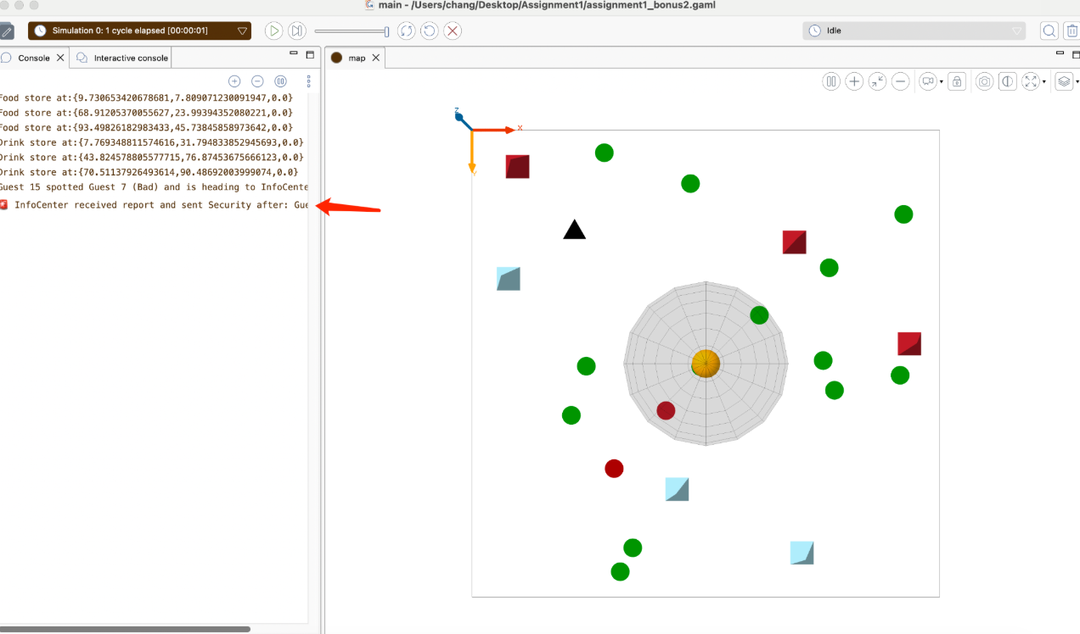

Screenshot B (right image):

Console continues with normal hunger/thirst logs plus Security actions.

When Security reaches the target, it prints the terminal message, e.g.,

Guest 4: exterminated by Security! (bad guest removed).

On the map, the black triangle is near the former target location; the bad guest has disappeared.

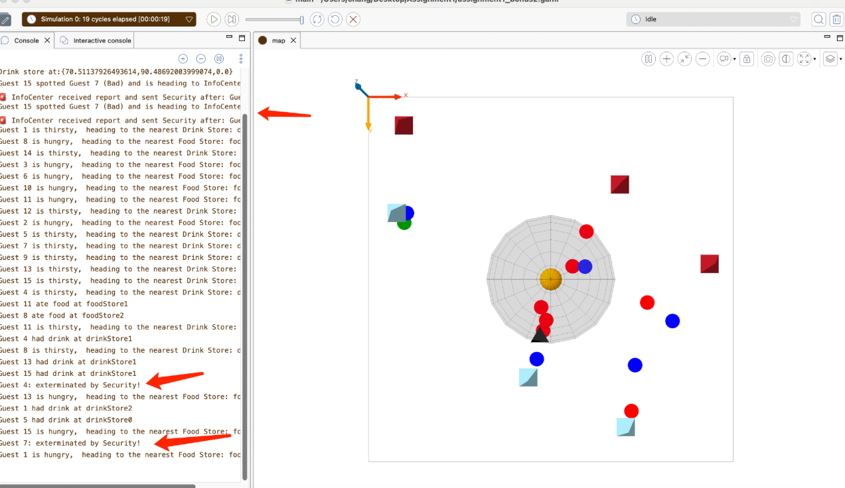

3) Short interpretation of the result

The pipeline works end-to-end: a normal guest detects a nearby bad guest, reports it to the InfoCenter, which then dispatches Security.

Security successfully chases and removes the reported bad agent (confirmed by the exterminated by Security! log and the disappearance of the red agent from the scene).

These outputs match the requirements of Challenge 2.

**Use Case 2 — Security Chase & Removal (Black Triangle, Faster Chase)**

1) Input description

Run assignment1_bonus2.gaml with experiment main, keep other parameters default.

Increase speed_security to speed_guests * 2.0, then start the simulation.

Wait until a normal guest detects a bad guest within report_distance and reports to the InfoCenter.

2) Screenshots of execution/output

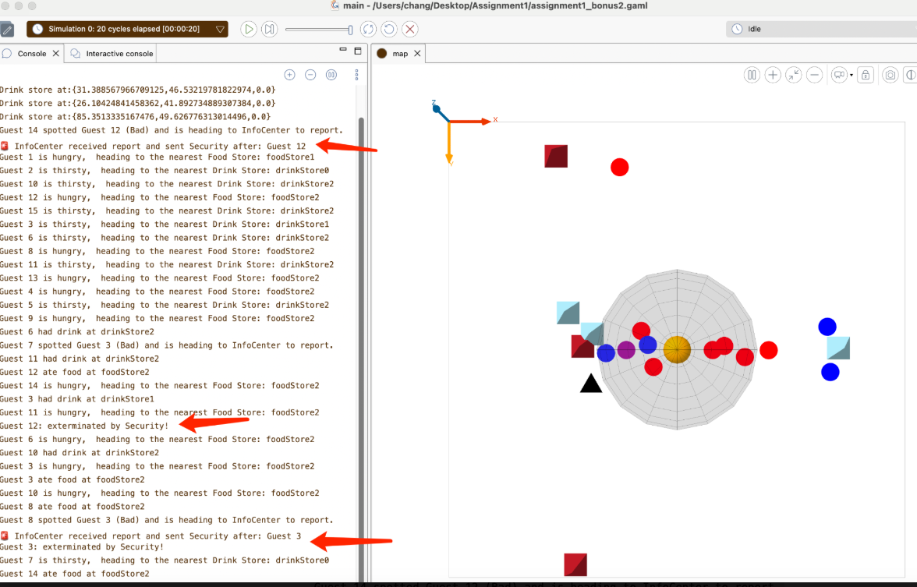

Map: the black triangle Security is approaching or in contact with a dark-red bad guest; the bad guest then disappears from the scene.

Console: the full three-step log chain appears:

Spot & report — Guest X spotted Guest Y (Bad) and is heading to InfoCenter to report.

Dispatch — InfoCenter received report and sent Security after: Guest Y

Extermination — Guest Y: exterminated by Security!

3) Short interpretation of the result

The screenshots and logs jointly demonstrate the closed loop report → dispatch → chase → removal (die). With the higher speed (speed_security = 2.0 * speed_guests), Security reaches and clears the target more quickly.

This use case confirms the core logic of Challenge 2: reports are correctly routed to the InfoCenter, and Security reliably chases and removes the reported bad guest.

**Use Case 3 — Sensitivity to report_distance (small vs. large)**

Input.

Run two simulations with different reporting radii (other parameters default; run ~600–1,000 steps each):

Run A: report_distance = 5.0 (small radius).

Run B: report_distance = 20.0 (large radius).

Screenshot(s).

Map A (small radius) — the black triangle (Security) remains idle more often; fewer purple-reporting guests are visible; bad (dark-red) guests persist longer. Console shows sporadic “spotted … heading to InfoCenter” and fewer “InfoCenter received report … sent Security” / “exterminated by Security!” lines.

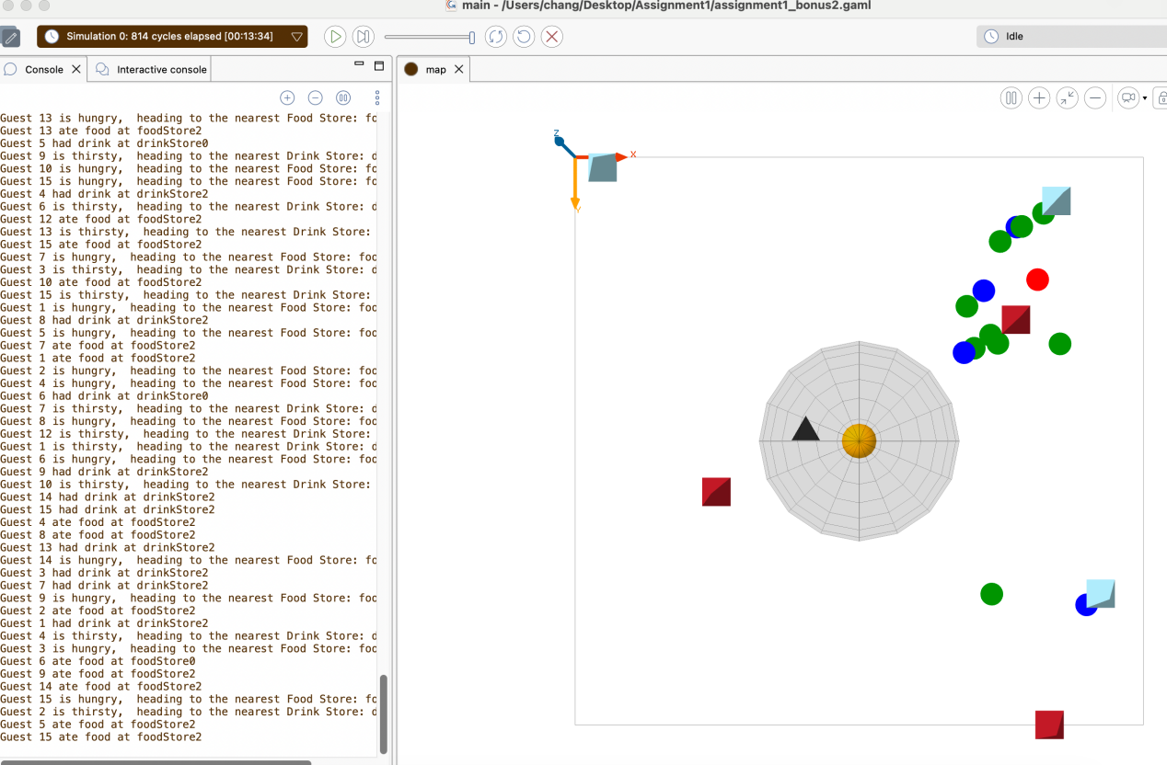

Map B (large radius) — more frequent reporting and pursuits; Security moves more; bad guests are removed sooner. Console shows many “spotted …”, “InfoCenter received report … sent Security after: Guest X”, and “Guest X: exterminated by Security!” entries.

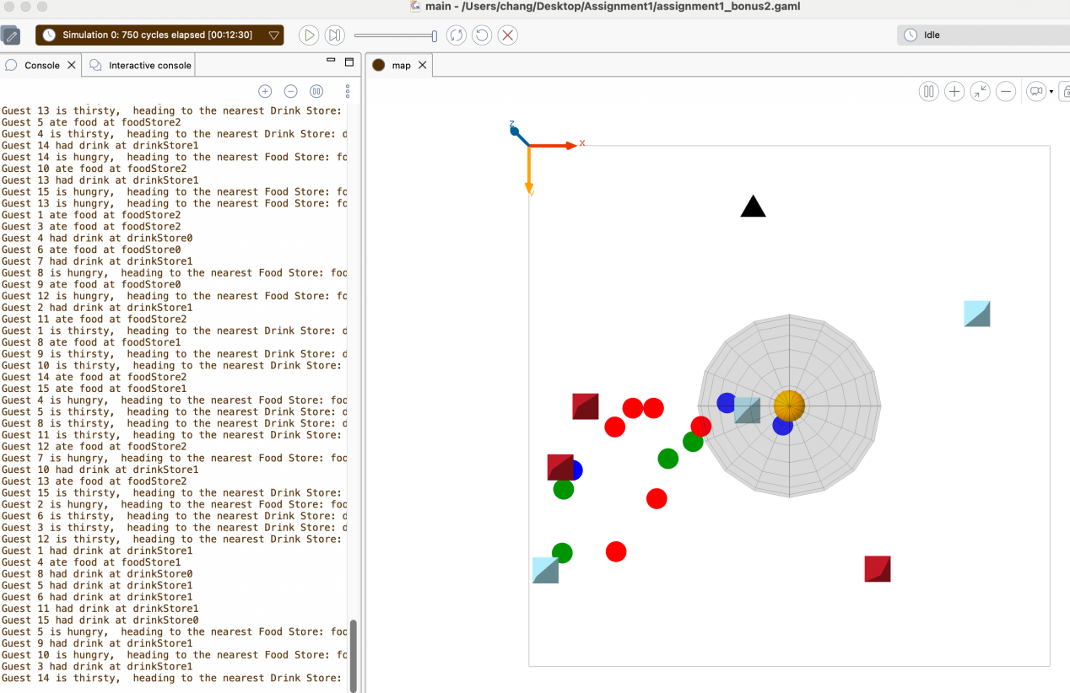

Interpretation.

A larger report_distance triggers more frequent detections and dispatches, which increases the number of chases and reduces the survival time of bad guests; a smaller radius does the opposite. This use case demonstrates how report_distance controls the overall vigilance level of the system.

**Use Case 4 — Multiple reporters for one bad guest (single dispatch, no duplicates)**

Input.

To make it easier for several guests to notice the same bad guest, increase report_distance to 15–20 and (optionally) start the bad guest near the central activity zone so multiple normals come within range at the same time.

Screenshot.

Console (key evidence):

Several “spot & report” messages for the same target, e.g.

Guest 1 spotted Guest 10 (Bad) and is heading to InfoCenter to report.

Guest 7 spotted Guest 3 (Bad) and is heading to InfoCenter to report.

Exactly one dispatch message (no duplicate orders):

InfoCenter received report and sent Security after: Guest 10

A single extermination message:

Guest 10: exterminated by Security!

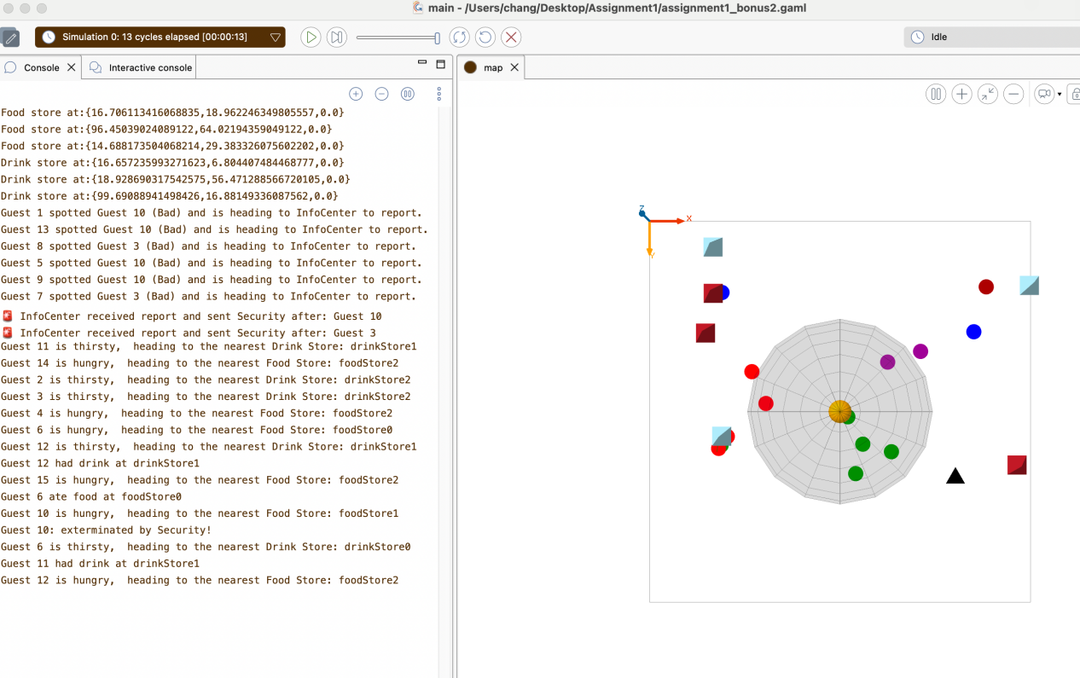

Map:

A. Multiple purple normal guests (reporting state) simultaneously heading toward the InfoCenter; the black triangle (Security) is still idle or just launched.

B. Later frame showing Security chasing the same red bad guest and that guest subsequently disappears from the scene after removal.

Interpretation.

This run demonstrates that several normals can detect and report the same bad guest concurrently, yet the InfoCenter issues only one task to Security (the target isn’t duplicated in Security.targets). Finally, there is one extermination for that target. The behavior confirms correct de-duplication of reports and single dispatch per bad guest.

**5. Final Remarks**

**What we learned**

We learned how to structure GAMA models (model → global → species → experiment) and run an iterate-observe loop using displays, monitors, and console logs. We defined and created agents with attributes and visual aspects, scheduled behavior with reflex (auto each step, when: conditions) versus callable actions, and drove motion via skills:[moving] with goto and wander. We used spatial and set operators (closest_to, at_distance, distance_to, where, sort_by, collect, mean) to express decisions declaratively. We practiced context switching and messaging with ask, safely referencing myself and self. We monitored KPIs through monitor, printed key events with write, and improved reuse with types (point, rgb, list<T>) and species inheritance (parent:). Overall, we internalized agent creation, communication and get the tangible experience of creating simulations model.

**Limitations / Improvements**

The guests’ hunger/thirst decay and speed are currently global constants, whereas real populations are heterogeneous; consider introducing individual variability (parameter distributions/profiles).

The memory mechanism only records “stores visited” and does not account for dynamic weights such as service quality, queues, or crowding; extend it to a weighted memory with temporal decay.

Logs are plain text and require manual comparison for analysis; add time-series statistics and charts (e.g., response time to incidents, removal success rate, average memory size over time).

**Extra comments**

For more data and evaluation of challenge1，please refer to the document memory.pdf